Ex.no:1.a  Date: | DATA DEFINITION LANGUAGE

AIM:
To execute the various Data Definition Language commands in RDBMS.

ALGORITHM:

Step 1: Start.
Step 2: Go to SQL.
Step 3: Enter the user name and password.
Step 4: Type the commands for creating tables and perform various operations on
the tables.
Step 5: The output is displayed.
Step 6: Stop.

1. CREATE TABLE:
Syntax: create table table_name(column1 data type,column2 data type,…);

Description: The create table statement is used to create a table in database.

SQL> create table pers(p_id number,lastname varchar2(10),firstname
varchar2(10),address varchar2(10));

Output: Table created.

SQL> desc pers

Name Null? Type
--------------------------------- -------- ------------------------
P_ID NUMBER
LASTNAME VARCHAR2(10)
FIRSTNAME VARCHAR2(10)
ADDRESS VARCHAR2(10)

2. ALTER TABLE:
To add a column:

Syntax: alter table table_name add column_name datatype;

Description: To add a column into a database.

SQL> alter table pers add city number;

Output: Table altered.

SQL> desc pers

Name Null? Type
---------------------------------- -------- -------------------------
P_ID NUMBER
LASTNAME VARCHAR2(10)
FIRSTNAME VARCHAR2(10)
ADDRESS VARCHAR2(10)
CITY NUMBER

To change the datatype of a column:

Syntax: alter table table_name modify column_name datatype;

Description: To change the datatype of a column.

SQL> alter table pers modify city varchar2(10);

Output: Table altered.

SQL> desc pers

Name Null? Type
---------------------------------- -------- --------------------------
P_ID NUMBER
LASTNAME VARCHAR2(10)
FIRSTNAME VARCHAR2(10)
ADDRESS VARCHAR2(10)
CITY VARCHAR2(10)

To delete a column:

Syntax: alter table table_name drop column column_name;

Description: To delete a column.

SQL> alter table pers drop column city ;

Output: Table altered.

SQL> desc pers

Name Null? Type
---------------------------------- -------- --------------------------
P_ID NUMBER
LASTNAME VARCHAR2(10)
FIRSTNAME VARCHAR2(10)
ADDRESS VARCHAR2(10)

3. DROP TABLE:
Syntax: drop table table_name;

Description: To delete the entire table.

SQL> drop table pers;

Output: Table dropped.

SQL> desc pers

ERROR:
ORA-04043: object pers does not exist

Truncate table

Syntax: truncate table table_name;

Description: To delete the data inside the table and not the table itself.

SQL> truncate table pers;

Output: Table truncated.

SQL> desc pers

Name Null? Type
---------------------------------- -------- -------------------------
P_ID NUMBER
LASTNAME VARCHAR2(10)
FIRSTNAME VARCHAR2(10)
ADDRESS VARCHAR2(10)

RESULT:
Thus the various Data Definition Language commands were executed successfully and verified.

Ex.no:1b  Date: | DATA MANIPULATION LANGUAGE

AIM:
To execute the various Data Manipulation Language commands in RDBMS.

ALGORITHM:

Step 1: Start.
Step 2: Go to SQL.
Step 3: Enter the user name and password.
Step 4: Type the commands to manipulate tables and perform various operations
on the tables.
Step 5: The output is displayed.
Step 6: Stop.

1. INSERT INTO:
To insert values in all field
Syntax: insert into table_name values(value1,values 2,..);

Description: To insert new data into database.

SQL> insert into pers values(1,'kalai','sasi','tirupur');

Output: 1 row created.

SQL> select *from pers;

P_ID LASTNAME FIRSTNAME ADDRESS
------- ---------------- ----------------- --------------
1 kalai sasi tirupur

To insert values in particular field
Syntax: insert into table_name(field names)values(value 1,…);

Description: To insert values in particular field.

SQL> insert into pers(p_id,firstname)values(3,’sasi’);

Output: 1 row created.

SQL> select *from pers;

P_ID LASTNAME FIRSTNAME ADDRESS
------ ---------------- ----------------- --------------
1 kala sasi tirupur
3 sasi

To insert values dynamically
Syntax: insert into table_name(&field name1,& field name2);

Description: To insert data into database dynamically.

SQL> insert into pers values(&p_id,’&lastname’,’&firstname’,’&address’);
Enter the value for p_id=2
Enter the value for lastname=vani
Enter the value for firstname=kalai
Enter the value for address=tirupur

Output: 1 row created.

SQL> select *from pers;

P_ID LASTNAME FIRSTNAME ADDRESS
------- ---------------- ----------------- --------------
1 kalai sasi tirupur
3 sasi
2 vani kalai tirupur

2. UPDATE:

Syntax: update table_name set column_name=value where some column=some value;

Description: To update data in a database.

SQL> update pers set lastname='kala' where p_id=1;

Output: 1 row updated.

SQL> select *from pers;

P_ID LASTNAME FIRSTNAME ADDRESS
------ ---------------- ----------------- --------------
1 kala sasi tirupur
3 sasi
2 vani kalai tirupur

3. DELETE:

Syntax: delete from table_name where column_name=value;

Description: To delete data from database.

SQL> delete from pers where p_id=3;

Output: 1 row deleted.

SQL> select *from pers;

P_ID LASTNAME FIRSTNAME ADDRESS
------ ---------------- ----------------- --------------
1 kala sasi tirupur
2 vani kalai tirupur

4. SELECT

Syntax: select *from table_name;

Description: To extract data from a database.

SQL> select *from pers;

Output:

P_ID LASTNAME FIRSTNAME ADDRESS
------ ---------------- ------------------ --------------
1 kala sasi tirupur
2 vani kalai tirupur
3 kumar sasi chennai

Like :

Syntax: select field_name from table_name where field_name like pattern;
Description: To display the data in the given pattern.

SQL> select losal from salgrade where losal like '1%';

Output:

LOSAL
----------
1201
1401

In:

Syntax: select *from table_name where field_name in;

Description: To display the particular record.

SQL> select * from salgrade where grade in (2);

Output:

GRADE LOSAL HISAL
------------ ------------- ----------
2 1201 1400

Between:

Syntax: select *from table_name where field_name between value1 and value2;

Description: To display the records between the mentioned values.

SQL> select * from salgrade where grade between 1 and 3;

Output:

GRADE LOSAL HISAL
------------ ------------- ----------
1 700 1200
2 1201 1400
3 1401 2000

Where:

Syntax: select *from table_name where condition;

Description: To display the record that satisfies the condition.

SQL> select * from salgrade where grade>3;

Output:

GRADE LOSAL HISAL
------------ ------------- ----------
4 2001 3000
5 3001 9999

Distinct:

Syntax: select distinct field_name from table_name;

Description: To display distinct field.

SQL> select distinct grade from salgrade;

Output:

GRADE
----------
1
2
3
Order by ascending:

Syntax: select *from table_name order by field_name asc;

Description: To display the records in ascending order.

SQL> select * from salgrade order by grade asc;

Output:
GRADE LOSAL HISAL
------------ ------------- ----------
1 700 1200
2 1201 1400
3 1401 2000
4 2001 3000
5 3001 9999

Order by descending:

Syntax: select *from table_name order by field_name desc;

Description: To display the records in descending order.

SQL> select * from salgrade order by grade desc;

Output:

GRADE LOSAL HISAL
------------ ------------- ----------
5 3001 9999
4 2001 3000
3 1401 2000
And:

Syntax: select *from table_name where condition1 and condition2;

Description: To display the data that satisfies both conditions.

SQL> select * from salgrade where losal=700 and hisal=1200;

Output:

GRADE LOSAL HISAL
------------ ------------- ----------
1 700 1200
Or:

Syntax: select *from table_name where condition1 or condition2;

Description: To display the data that satisfies any one condition.

SQL> select * from salgrade where losal=700 or hisal=9999;

Output:
GRADE LOSAL HISAL
------------ ------------- ----------
1 700 1200
5 3001 9999
RESULT:
Thus the various Data Definition Language commands were executed successfully and verified.

Ex.no:1c  Date: | TRANSACTION CONTROL STATEMENTS

AIM:
To execute the various Transaction Control Language commands in RDBMS.

ALGORITHM:

Step 1: Start.
Step 2: Go to SQL.
Step 3: Enter the user name and password.
Step 4: Type the commands for creating tables and perform various operations on
the tables using Transaction Control Language commands.
Step 5: The output is displayed.
Step 6: Stop.

PROGRAM:

- COMMIT − to save the changes.
Create a table customers (c_id,c_name,age,address) and insert five records. Then give the following queries.

SQL> delete from customers where age = 25;
SQL> commit;

- ROLLBACK − to roll back the changes.
Create a table customers (c_id,c_name,age,address) and insert five records. Then give the following queries.

SQL> delete from customers where age = 25;
SQL> rollback;

- SAVEPOINT − creates points within the groups of transactions in which to rollback.

Create a table customers (c_id,c_name,age,address) and insert five records. Then give the following queries.

SQL> delete from customers where c_id = 1;
SQL> savepoint sp1;
SQL> delete from customers where c_id = 2;
SQL> delete from customers where c_id = 5;
SQL> rollback to sp1;

RESULT:
Thus the system transaction control statements was executed and verified successfully.
Ex.no:2  Date: | SIMPLE QUERIES, NESTED QUERIES, SUB QUERIES AND JOIN QUERIES

AIM:
To execute the various join queries and nested queries.

ALGORITHM:
Step 1: Start.
Step 2: Go to SQL.
Step 3: Enter the user name and password.
Step 4: Type the commands for executing various join queries and nested queries.
Step 5: The output is displayed.
Step 6: Stop.

SIMPLE QUERIES:

- SELECT query:

Syntax: select column_name from table_name where condition;

Description: To display the content of a table.

SQL> select *from stud1; SQL>select *from stud2;

SNO REGNO NAME SNO ADDRESS CITY
----- -------------------- -------------------- ------- ------------------ -----------------
1 8001 abi 1 gandhi nagar tirupur
2 8002 arun 3 raja nagar chennai
3 8003 kalai 4 giri nagar coimbatore

SQL> select * from salgrade where grade>3;

Output:

GRADE LOSAL HISAL
------------ ------------- ----------
4 2001 3000
5 3001 9999

JOIN QUERIES:

Rules to perform join operation:
Before performing the join operations two tables should be connected using the primary and foreign key as following

SQL> select *from stud1; SQL>select *from stud2;

SNO REGNO NAME SNO ADDRESS CITY
----- -------------------- -------------------- ------- ----------------- -------------------
1 8001 abi 1 gandhi nagar tirupur
2 8002 arun 3 raja nagar chennai
3 8003 kalai 4 giri nagar coim
4 8010 sasi 5 kvr nagar tirupur

1. INNER JOIN:
Syntax: select column_name(s) from table_name1 inner join table_name2 on
table_name1.column_name=table_name2.column_name;

Description: To return rows when there is at least one match in both tables.

SQL> select stud1.regno,stud1.name,stud2.city from stud1 inner join stud2 on stud1.sno=stud2.sno;

Output:

REGNO NAME CITY
---------- -------------------- --------------------
8001 abi tirupur
8003 kalai chennai
8010 sasi coimbatore

2. LEFT JOIN:
Syntax: select column_name(s) from table_name1 left join table_name2 on
table_name1.column_name=table_name2.column_name;

Description:To return all rows from the left table (table_name1), even if there are
no matches in the right table (table_name2).

SQL> select regno,name,city from stud1 left join stud2 on stud1.sno=stud2.sno;

Output:

REGNO NAME CITY
---------- -------------------- --------------------
8001 abi tirupur
8003 kalai chennai
8010 sasi coimbatore
8002 arun

3. RIGHT JOIN:
Syntax: select column_name(s) from table_name1 right join table_name2 on
table_name1.column_name=table_name2.column_name;

Description: To return all rows from the right table (table_name2), even if there are
no matches in the left table (table_name1).

SQL> select regno,name,city from stud1 right join stud2 on stud1.sno=stud2.sno;

Output:

REGNO NAME CITY
---------- ------------------ --------------------
8001 abi tirupur
8003 kalai chennai
8010 sasi coimbatore
tirupur
4. FULL JOIN:
Syntax: select column_name(s) from table_name1 full join table_name2 on
table_name1.column_name=table_name2.column_name;

Description:To return rows when there is a match in one of the tables.

SQL> select regno,name,city from stud1 full join stud2 on stud1.sno=stud2.sno;

Output:

REGNO NAME CITY
---------- ----------------- --------------------
8001 abi tirupur
8003 kalai chennai
8010 sasi coimbatore
8002 arun tirupur

NESTED QUERIES and SUB QUERIES:

1. CREATE A TABLE:
Syntax: create table table_name2 as select *from table_name1;

Description: To create a new table as like the table that already exsist.

SQL> desc student;

Name Null? Type
---------------------------------- -------- ----------------------------
SNO NUMBER
REGNO NUMBER
NAME VARCHAR2(20)

SQL> create table stud as select *from student;

Output : Table created.

SQL> desc stud;

Name Null? Type
---------------------------------- -------- ----------------------------
SNO NUMBER
REGNO NUMBER
NAME VARCHAR2(20)
2. INSERTING VALUES:
Syntax: insert into table_name2 select *from table_name1;

Description: To insert the values from one table to another table.

SQL> select *from student;

SNO REGNO NAME
-------- -------------- ----------------
1 8010501 arun
2 8010502 abi
3 8010503 kalai

SQL> insert into stud select *from student;

Output: 3 rows created.

SQL> select *from stud;

SNO REGNO NAME
-------- -------------- ----------------
1 8010501 arun
2 8010502 abi
3 8010503 kalai

3. DISPLAYING THE CONTENTS:
Syntax: select column_name from table_name2 where column_name in(select
column_name from table_name1);

Description: To display the content of a table by comparing two tables.

SQL> select *from stud1; SQL>select *from stud2;

SNO REGNO NAME SNO ADDRESS CITY
----- -------------------- -------------------- ------- ------------------ -----------------
1 8001 abi 1 gandhi nagar tirupur
2 8002 arun 3 raja nagar chennai
3 8003 kalai 4 giri nagar coimbatore

SQL> select name from stud1 where sno in (select sno from stud2);

Output:
NAME
--------------------
abi
kalai

RESULT:
Thus the various join queries and nested queries were executed successfully and verified.

Ex.no:3a  Date: | VIEWS

AIM:
To create views by using SQL.

ALGORITHM:
Step 1: Start.
Step 2: Go to SQL.
Step 3: Enter the user name and password.
Step 4: Type the commands for creating,updating and droping views
Step 5: The output is displayed.
Step 6: Stop.

1. CREATE VIEW:
Syntax: create view view_name as select column_name(s) from table_name
where condition;

Description: To create a view from the table or another view.

SQL> create view stud1 as select regno,name from student where mark2>75;

Output: View created.

To view the view
Syntax: select *from view_name;

Description: To view the view that is created.

SQL> select *from stud1;

Output:

REGNO NAME
---------- --------------------
8001 arun
8003 kalai
8004 kumar
2. UPDATE VIEW:
Syntax: create or replace view view_name as select column_name(s) from
table name where condition;

Description: To update the view that is already created.

SQL> create or replace view stud1 as select sno,regno,name from student
where mark2>75;

Output: View created.

SQL> select *from stud1;

SNO REGNO NAME
---------- ---------- --------------------
1 8001 arun
3 8003 kalai
4 8004 kumar
5 8005 sasi

3. DROP VIEW:
Syntax: drop view view_name;

Description:To drop the view that is created.

SQL> drop view stud1;

Output: View dropped.

RESULT:
Thus the views were created successfully and verified.

Ex.no:3b  Date: | SEQUENCE IN SQL

AIM:
To create a sequence in SQL.

ALGORITHM:
Step 1: Start.
Step 2: Go to SQL.
Step 3: Enter the user name and password and create a sequence.
Step 4: Execute the sequence and create a table to apply the sequence created.
Step 5: The output is displayed.
Step 6: Stop.

PROGRAM:
- Create a sequence query in ascending order.
CREATE SEQUENCE sequence_1
start with 1
increment by 1
minvalue 0
maxvalue 100
cycle;

- To use sequence create a table named students with columns as id and name.
SQL> create table students ( ID number, NAME varchar2(20) );

- Insert values into table
SQL> insert into students VALUES(sequence_1.nextval,'Ramesh');
SQL> insert into students VALUES(sequence_1.nextval,'Suresh');

OUTPUT:

SQL> select * from students;

| ID | NAME |
------------------------
| 1 | Ramesh |
| 2 | Suresh |

RESULT:
Thus the sequence was executed and verified successfully.
Ex.no:3c  Date: | SYNONYMS IN SQL

AIM:
To create a synonyms in SQL.

ALGORITHM:
Step 1: Start.
Step 2: Go to SQL.
Step 3: Enter the user name and password and create a synonyms.
Step 4: create a synonym for a table and execute the select query for the synonym
table name.
Step 5: The output is displayed.
Step 6: Stop.

PROGRAM:
create synonym students for student_table;

OUTPUT:

SQL> select * from students;

| ID | NAME |
------------------------
| 1 | Ramesh |
| 2 | Suresh |

RESULT:
Thus the synonym was executed and verified successfully.

Ex.no:4a  Date: | IMPLICIT CURSOR

AIM:
To create a implicit cursor using PL/SQL.

ALGORITHM:
Step 1: Start.
Step 2: Go to SQL.
Step 3: Enter the user name and password and create a table to apply implicit cursor.
Step 4: To open the notepad give the command as ed filename.sql.
Step 5: Type the program using implicit cursor in notepad and save it.
Step 6: To execute the program specify the full path of the file that is saved.
Step 7: The output is displayed.
Step 8: Stop.

PROGRAM:
DECLARE
total_rows number(2);
BEGIN
UPDATE customers
SET salary = salary + 500;
IF sql%notfound THEN
dbms_output.put_line('no customers selected');
ELSIF sql%found THEN
total_rows := sql%rowcount;
dbms_output.put_line( total_rows || ' customers selected ');
END IF;
END;
/

OUTPUT:

SQL> @F:/implicit.sql

6 customers selected

PL/SQL procedure successfully completed.

RESULT:
Thus the system implicit cursor was executed and verified successfully.

Ex.no:4b  Date: | EXPLICIT CURSOR

AIM:
To create a user defined exception using PL/SQL.

ALGORITHM:
Step 1: Start.
Step 2: Go to SQL.
Step 3: Enter the user name and password and create a table to apply explicit cursor.
Step 4: To open the notepad give the command as ed filename.sql.
Step 5: Type the program using explicit cursor in notepad and save it.
Step 6: To execute the program specify the full path of the file that is saved.
Step 7: The output is displayed.
Step 8: Stop.
PROGRAM:
DECLARE
c_id customers.id%type;
c_name customerS.No.ame%type;
c_addr customers.address%type;
CURSOR c_customers is
SELECT id, name, address FROM customers;
BEGIN
OPEN c_customers;
LOOP
FETCH c_customers into c_id, c_name, c_addr;
EXIT WHEN c_customers%notfound;
dbms_output.put_line(c_id || ' ' || c_name || ' ' || c_addr);
END LOOP;
CLOSE c_customers;
END;
/
OUTPUT:

SQL> @F:/explicit.sql

1 Ramesh Ahmedabad
2 Ahilan Delhi
3 Kowshik Mumbai

PL/SQL procedure successfully completed.

RESULT:
Thus the explicit cursor was executed and verified successfully.

Ex.no:5a  Date: | FIBONACCI SERIES USING PROCEDURE

AIM:
To write a PL/SQL program to generate the Fibonacci series using procedure.

ALGORITHM:

Step 1: Start.
Step 2: Go to SQL.
Step 3: Enter the user name and password.
Step 4: To open the notepad give the command as ed filename.sql.
Step 5: Type the program to generate the Fibonacci series and save it.
Step 6: To execute the program specify the full path of the file that is saved.
Step 7: The output is displayed.
Step 8: Stop.

PROGRAM:
Create or replace procedure fibo (n number)
IS
f1 number:=-1;
f2 number:=1;
f3 number;
i number;
BEGIN
dbms_output.put_line('THE FIBONACCI SERIES IS:');
for i in 1..n loop
f3:=f1+f2;
dbms_output.put_line(f3);
f1:=f2;
f2:=f3;
end loop;
END;
/

OUTPUT:

SQL> @G:\Lab\Dbms\fibonacci.sql

Procedure created.

SQL> exec fibo (10)

THE FIBONACCI SERIES IS:
0
1
1
2
3
5
8
13
21
34

PL/SQL procedure successfully completed.

RESULT:
Thus a PL/SQL program to generate the Fibonacci series using procedure was executed successfully and verified.
Ex.no:5b  Date: | FACTORIAL OF A NUMBER USING FUNCTION

AIM:
To write a PL/SQL program to find the factorial of a number using function.

ALGORITHM:

Step 1: Start.
Step 2: Go to SQL.
Step 3: Enter the user name and password.
Step 4: To open the notepad give the command as ed filename.sql.
Step 5: Type the program to find factorial of a number and save it.
Step 6: To execute the program specify the full path of the file that is saved.
Step 7: The output is displayed.
Step 8: Stop.

PROGRAM:
Create or replace function fact (num number) return number
IS
i number;
f1 number:=1;
BEGIN
for i in 1..num loop
f1:=f1*i;
end loop;
return f1;
END;
/

OUTPUT:

SQL> @G:\Lab\Dbms\factorial.sql

Function created.

SQL> select fact (7) from dual;

FACT (7)
----------
5040

RESULT:
Thus a PL/SQL program to find the factorial of a number using function was executed successfully and verified.
Ex.no:6a  Date: | TRIGGER –DISPLAYING MESSAGE

AIM:
To write trigger for displaying the message.

ALGORITHM:
Step 1: Start.
Step 2: Go to SQL.
Step 3: Enter the user name and password and create a table to apply trigger..
Step 4: To open the notepad give the command as ed filename.sql.
Step 5: Type the program using trigger to display a meesage in notepad and
save it.
Step 6: To execute the program specify the full path of the file that is saved.
Step 7: The output is displayed.
Step 8: Stop.
PROGRAM:
create or replace trigger stu_holiday
before insert or update or delete on student for each row
BEGIN
if to_char(sysdate,'DY')='MON'then
dbms_output.put_line('Today is holiday');
end if;
END;
/
OUTPUT:

SQL> create table student(regno number,name varchar2(20));
Table created.

SQL> @h:\tg1.sql
Trigger created.

SQL> insert into student values(1004,'hema');
Today is holiday

1 row created.

RESULT:
Thus the trigger to display the message was executed successfully and verified.

Ex.no:6b  Date: | DISPLAYINY SYSTEM DATE,USER_NAME,ACTION

AIM:
To write a trigger for displaying the system date,user_name and action.

ALGORITHM:

Step 1: Start.
Step 2: Go to SQL.
Step 3: Enter the user name and password and create a table to apply trigger..
Step 4: To open the notepad give the command as ed filename.sql.
Step 5: Type the program using trigger to display the system date,user_name and
action in notepad and save it.
Step 6: To execute the program specify the full path of the file that is saved.
Step 7: The output is displayed.
Step 8: Stop.

PROGRAM:
create or replace trigger empaudit
after insert or update or delete on emp
DECLARE
action varchar2(20);
BEGIN
if inserting then
action:='Added employee';
elsif updating then
action:='update';
elsif deleting then
action:='deleted';
end if;
insert into empauditor values(sysdate,user,action);
END;
/

OUTPUT:

SQL> create table empauditor(audit_date date,audit_user varchar2(30),audit_desc
varchar2(25);

Table created.

SQL> create table emp(empid number,empname varchar2(20));

Table created.

SQL> @h:\tg2.sql

Trigger created.

SQL> insert into emp values(2001,'ram');

1 row created.

SQL> update emp set empid=2003 where empname='ram';

1 row updated.

SQL> select *from empauditor;

AUDIT_DATE AUDIT_USER AUDIT_DESC
------------------- ------------------------ -------------------------
19-APR-10 SCOTT Added employee
19-APR-10 SCOTT update

RESULT:
Thus the trigger for displaying the system date,user_name and action was executed successfully and verified.

Ex.no:7a  Date: | SYSTEM DEFINED EXCEPTION

AIM:
To create a system defined exception using PL/SQL.

ALGORITHM:
Step 1: Start.
Step 2: Go to SQL.
Step 3: Enter the user name and password and create a table to apply system
defined exception.
Step 4: To open the notepad give the command as ed filename.sql.
Step 5: Type the program using system defined exception in notepad and save it.
Step 6: To execute the program specify the full path of the file that is saved.
Step 7: The output is displayed.
Step 8: Stop.
PROGRAM:
DECLARE
c_id customers.id%type := 8;
c_name customerS.Name%type;
c_addr customers.address%type;

BEGIN
SELECT name, address INTO c_name, c_addr
FROM customers
WHERE id = c_id;
DBMS_OUTPUT.PUT_LINE ('Name: '|| c_name);
DBMS_OUTPUT.PUT_LINE ('Address: ' || c_addr);

EXCEPTION
WHEN no_data_found THEN
dbms_output.put_line('No such customer!');
WHEN others THEN
dbms_output.put_line('Error!');
END;
/

OUTPUT:

SQL> @F:/exp.sql

No such customer!

PL/SQL procedure successfully completed.

RESULT:
Thus the system defined exception was executed and verified successfully.

Ex.no:7b  Date: | USER DEFINED EXCEPTION

AIM:
To create a user defined exception using PL/SQL.

ALGORITHM:
Step 1: Start.
Step 2: Go to SQL.
Step 3: Enter the user name and password and create a table to apply user defined
exception.
Step 4: To open the notepad give the command as ed filename.sql.
Step 5: Type the program using user defined exception in notepad and save it.
Step 6: To execute the program specify the full path of the file that is saved.
Step 7: The output is displayed.
Step 8: Stop.
PROGRAM:

DECLARE
c_id customers.id%type := &cc_id;
c_name customerS.Name%type;
c_addr customers.address%type;
-- user defined exception
ex_invalid_id EXCEPTION;

BEGIN
IF c_id <= 0 THEN
RAISE ex_invalid_id;
ELSE
SELECT name, address INTO c_name, c_addr
FROM customers
WHERE id = c_id;
DBMS_OUTPUT.PUT_LINE ('Name: '|| c_name);
DBMS_OUTPUT.PUT_LINE ('Address: ' || c_addr);
END IF;

EXCEPTION
WHEN ex_invalid_id THEN
dbms_output.put_line('ID must be greater than zero!');
WHEN no_data_found THEN
dbms_output.put_line('No such customer!');
WHEN others THEN
dbms_output.put_line('Error!');
END;
/
OUTPUT:

SQL> @F:/exp1.sql

ID must be greater than zero!

PL/SQL procedure successfully completed.

RESULT:
Thus the user defined exception was executed and verified successfully.

Ex.no:8  Date: | DATABASE DESIGN USING ER MODELING AND NORMALIZATION

AIM:
To create a database using ER modeling and normalization.
BASIC TERMINOLOGIES:

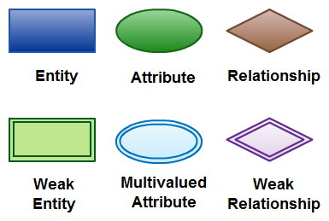

ER DIAGRAM: 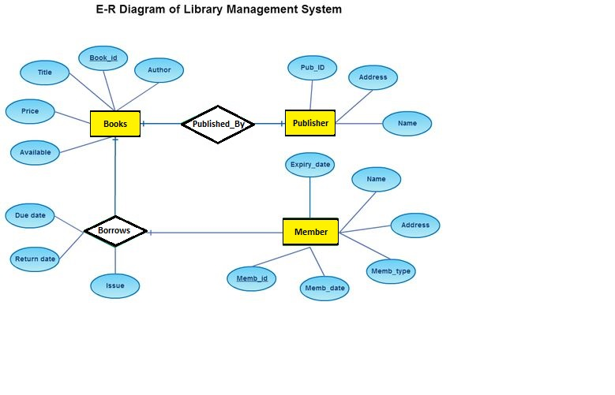 ER to Relational mapping:

Books(Author,Book_id,Title,Price,Available)
Publisher(Pub_id,Address,Name)
Member(Expiry_date,Name,Address,Memb_type, Memb_date, Memb_id)
Borrows(Book_id, Memb_id, Issue,Return_date,Due_date)
Normalization

Table_name:Publisher

Pub_id | Address | Name
B111 | Chennai | ABC
B222 | Trichy | CBA
B333 | Karur | BAC

Table Publisher is already normalized.Here Pub_id is set as primary key.

Table_name:Books

Author | Book_id | Title | Price | Available
Henry | I11 | Nature | 400 | Yes
Victor | I12 | CPP | 150 | Yes
Gopal | I13 | Embedded | 125 | No

Table Books has no 1NF but, as ‘available’ depends on topic partially, it has been removed. Also there is no transitive dependency found(3NF).

Table_name:Books(Normalised)

Author | Book_id | Title | Price
Henry | I11 | Nature | 400
Victor | I12 | CPP | 150
Gopal | I13 | Embedded | 125

Table_name:Member

Expiry_date | Name | Memb_type | Memb_id | Memb_date | Address
11/2/2020 | Rajesh | VIP | M667 | 10/9/2015 | Chennai/Tirupur
17/3/2022 | Ramesh | Platinum | M890 | 22/4/2012 | Salem/Madurai
21/8/2021 | Rakesh | Gold | M245 | 3/4/2018 | Tuticorin/Salem

‘Address’ column of table Member is atomic.So,it is splitted and hence normalized.Also,Expiry_date->Memb_date->Memb_type seems to be in transitive dependence.So,they are normalized.

Table_name:Member(Normalized)
Name | Memb_id | Address(1)
Rajesh | M667 | Chennai
Rajesh | M667 | Tirupur
Ramesh | M890 | Salem
Ramesh | M890 | Madurai
Rakesh | M245 | Tuticorin
Rakesh | M245 | Salem

Table_name:Borrows

Due_Date | Return_date | Issue
12/1/19 | 19/1/19 | Done
13/4/19 | 20/4/19 | Done
31/12/19 | 6/12/19 | Done

Table Borrows is already normalized.

RESULT:
Thus, an ER diagram for a database is designed and normalized successfully.

Ex.no:9  Date: | DATABASE CONNECTIVITY WITH FRONT END TOOLS

AIM:
To study about database connectivity with front end tools.

BASIC TERMINOLOGIES:

1)Front end - Host languages like c,c++,java,php etc,.
2)Backend - Databases such as mysql.sqllite,sqlplus etc,.
3)Query - Statements used to manage database data items.
4)SQL – Structured Query Language
5)DB – Database.

PROCEDURE:
Step 1: At first, the desired project is created with a front end language.
Step 2: When the design has been finished successfully, based on the usage, a database is connected to the front end.
Step 3: Before database connection, a database for that specific project is created.
Step 4: In that database, tables based on the requirement of the project are created.
Step 5: Then, at last, the linking statement SQL statement is embedded into the host language used for the project.

CODING:
<?php
$host = "localhost";
$user_name = "root";
$user_password = "";
$db_name = "kalisto";

$conn = mysqli_connect($host,$user_name,$user_password,$db_name);
if($conn)
echo "connection success";
else
echo "Connection failed";
?>

RESULT:
Thus, database connection with front end tools is implemented successfully.
Ex.no:10  Date: | INTERNAL MARKS CALCULATION PORTAL USING PHP AND MYSQL

AIM:
To develop a project for internal marks calculation portal using front end tool with backend tool.
PROCEDURE:

Step 1: In index page the user has to select Department, Year, Subject from a dropdown list.
Step 2: From the selected criteria, the user has to enter the marks for the specific subject is displayed.
Step 3: Marks of the students are entered into the marks field and ‘submit’ button is clicked.
Step 4: When ‘submit’ is clicked, the marks are stored into the specific table created for that subject in a database called int_marks.
Step 5: Steps 3 & 4 are repeated for all the other subjects.
Step 6: When all the marks for the subjects are entered, marks of individual subjects are displayed when view button is clicked.
Step 7: Also, a button called filter is also created to view a filtered marklist like failures, average, toppers and so on.

CODING:

Mark entry for Subject CA

<!DOCTYPE html>
<html>
<head>
<link rel="stylesheet" href="https://cdnjs.cloudflare.com/ajax/libs/meyer-reset/2.0/reset.min.css">
<style >
a
{
color: yellow;
text-align: center;
font-size: 18px;
}
</style>

<link rel="stylesheet" href="css/style1.css">
<?php
$conn = mysqli_connect('127.0.0.1','root','','int');
if(isset($_POST["submit"]))
{
$marks1 = $_POST["marks1"];
$marks2 = $_POST["marks2"];
$marks3 = $_POST["marks3"];
$marks4 = $_POST["marks4"];
$marks5 = $_POST["marks5"];
$marks6 = $_POST["marks6"];
$marks7 = $_POST["marks7"];
$marks8 = $_POST["marks8"];
$marks9 = $_POST["marks9"];
$marks10 = $_POST["marks10"];

$sql = "INSERT INTO subintca(regno,name,ca) VALUES (711217104001,'ABINAYA.R','$marks1'),(711217104002,'ANANDHI.H','$marks2'),(711217104003,'ANISH FATHIMA.A','$marks3'),(711217104004,'ANUSAYA.R','$marks4'),(711217104005,'AYURLIN MONISHA.K','$marks5'),(711217104006,'CHANDHINI DEVI.S','$marks6'),(711217104007,'CHANDRU.P','$marks7'),(711217104008,'DEEPAN KUMAR.D','$marks8'),(711217104009,'DEEPA TOPPU','$marks9'),(711217104010,'DHARANI.R','$marks10')";
if (mysqli_query($conn,$sql))
{
echo "Submission done successfully";
}
}
mysqli_close($conn);
?>
<title> CA Mark Entry</title>
</head>
<style >
h2
{
text-align: center;
font-size: 40px;
}
h4
{
text-align: left;
font-size: 26px;
}
h4
{
text-align: right;
font-size: 26px;
}
</style>
<body>
<div class="container">
<h2 >Marks Entry</h2>
<hr>
<form method="post">
<div class="form-group">
<h4 >Subject:Computer Architecture</h4>
<h4>Faculty:Mrs.Mallika</h5>
<form title="Marks" >
<table align="center" class="table table-hover table-responsive-sm">
<th>RegNo</th>
<th>Names</th>
<th>Marks</th>
<tr>
<td>711217104001</td>
<td>ABINAYA.R</td>
<td><input type="number" name="marks1" size=12 required max="100"></td>
</tr>
<tr>
<td>711217104002</td>
<td>ANANDHI.H</td>
<td><input type="number" name="marks2" size=12 required max="100"></td>
</tr>
<tr>
<td>711217104003</td>
<td>ANISH FATHIMA.A</td>
<td><input type="number" name="marks3" size=12 required max="100"></td>
</tr>
<tr>
<td>711217104004</td>
<td>ANUSAYA.R</td>
<td><input type="number" name="marks4" size=12 required max="100"></td>
</tr>
<tr>
<td>711217104005</td>
<td>AYURLIN MONISHA.K</td>
<td><input type="number" name="marks5" size=12 required max="100"></td>
</tr>
<tr>
<td>711217104006</td>
<td>CHANDHINI DEVI.S</td>
<td><input type="number" name="marks6" size=12 required max="100"></td>
</tr>
<tr>
<td>711217104007</td>
<td>CHANDRU.P</td>
<td><input type="number" name="marks7" size=12 required max="100"></td>
</tr>
<tr>
<td>711217104008</td>
<td>DEEPAN KUMAR.D</td>
<td><input type="number" name="marks8" size=12 required max="100"></td>
</tr>
<tr>
<td>711217104009</td>
<td>DEEPA TOPPU.A</td>
<td><input type="number" name="marks9" size=12 required max="100"></td>
</tr>
<tr>
<td>711217104010</td>
<td>DHARANI.R</td>
<td><input type="number" name="marks10" size=12 required max="100"></td>
</tr>
</table>
</form>
</div>
</div>
<script src='http://cdnjs.cloudflare.com/ajax/libs/jquery/2.1.3/jquery.min.js'></script>

<script src="js/index.js"></script>
</body>
</html>

Database Connection

<?php

$conn = mysqli_connect('127.0.0.1','root','','int');
if (mysqli_query($conn,$sql))
{
echo "Submission done successfully";

}mysqli_close($conn);

?>
Screenshots:

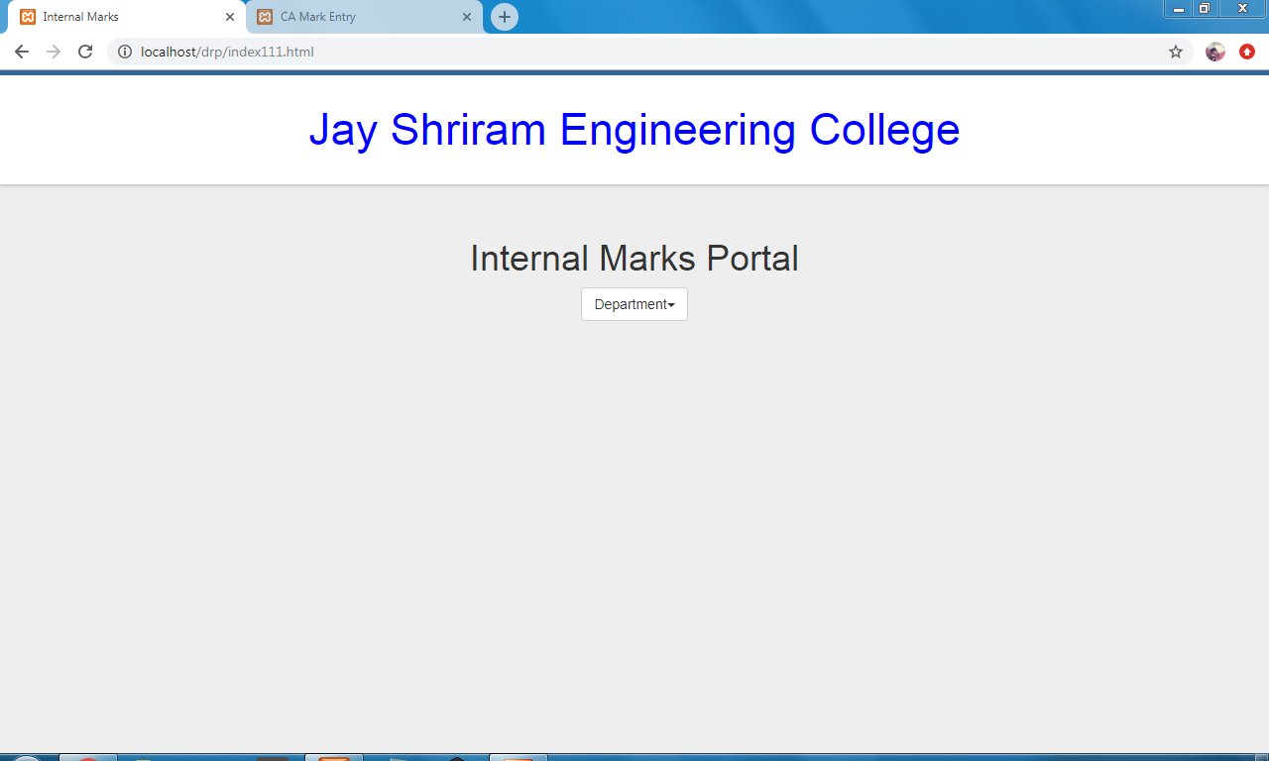

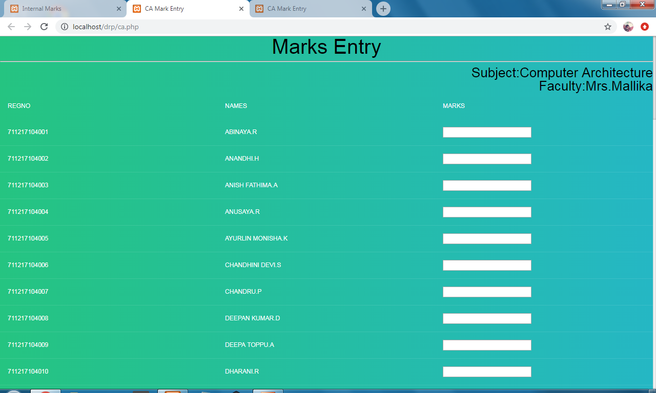

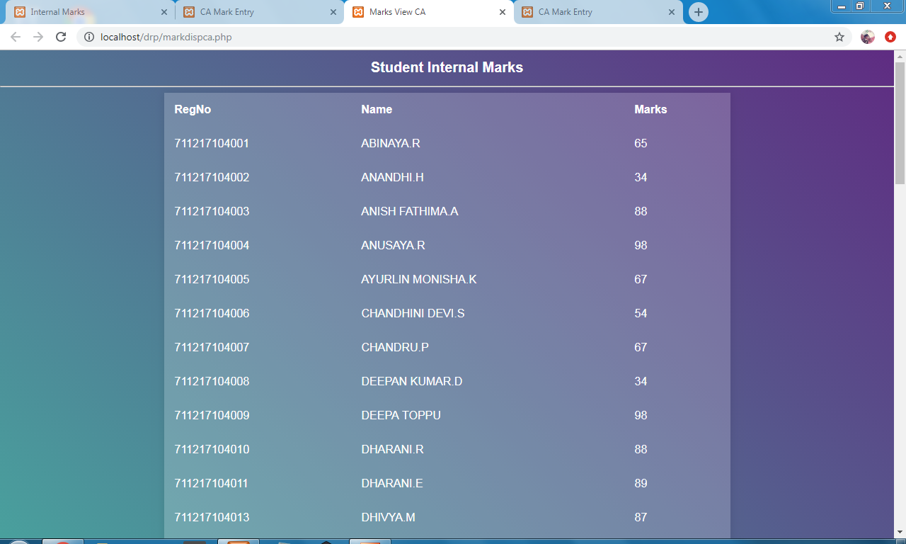

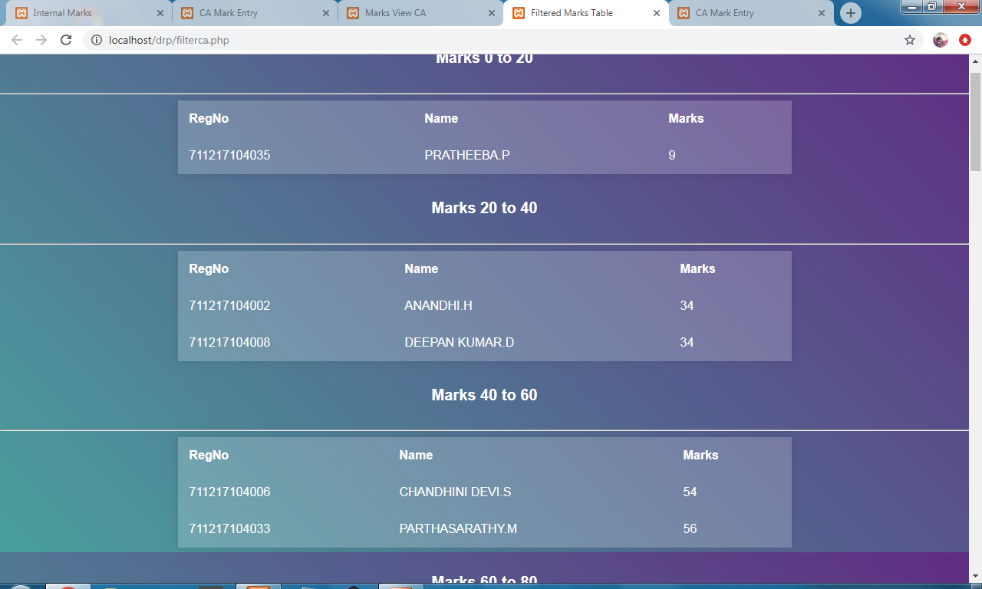

RESULT:
Thus, Internal Marks Portal - project has been created successfully.

CONTENT BEYOND SYLLABUS

Ex.no:11  Date: | DATA CONTROL LANGUAGE

AIM:
To execute the various Data Control Language queries in RDBMS.

ALGORITHM:

Step 1: Start.
Step 2: Go to SQL.
Step 3: Enter the user name and password.
Step 4: Type the queries for creating controls on tables.
Step 5: The output is displayed.
Step 6: Stop.

PROGRAM:

GRANT COMMAND

Description:

- GRANT command gives user's access privileges to the database.
- This command allows specified users to perform specific tasks.

Syntax:
GRANT <privilege list>
ON <relation name or view name>
TO <user/role list>;
Example :

GRANT Command
GRANT ALL ON employee
TO ABC;
REVOKE COMMAND

Description:

- REVOKE command is used to cancel previously granted or denied permissions.
- This command withdraw access privileges given with the GRANT command.
- It takes back permissions from user.

Syntax:
REVOKE <privilege list>
ON <relation name or view name>
FROM <user name>;
Example :

REVOKE Command
REVOKE UPDATE
ON employee
FROM ABC;

RESULT:
Thus, Data Control Language queries was executed successfully.

Ex.no:12  Date: | RAILWAY SYSTEM

AIM:
To develop a project for Railway System using RDBMS.

REQUIRE MENTS:

The railway network of our country is one of the most complex public establishments. To design a database solution for this network and make the management of the same more natural. The system should have the following pieces of information:
- Station names
- Tracks that connect those stations (to keep things simple, you can assume that only one track runs between two stations)
- Train IDs with names
- Schedules of the trains
The train schedules should have information on the stations from where the train starts and by when it reaches the destination. It should also include information on which stations it passes through during its journey.

To keep things simple, assume that every train completes its journey within a day, and they run daily. However, you’ll also need to store information on the sequence of the stations a train passes through. For example, if a train starts from Delhi and goes to Kolkata through Lucknow, then you’ll need to add the arrival and departure times of the train for all these stations. Keeping the stations in sequence will allow easy management of trains and their data.

Till here, the project is rather easy. You can make it more challenging by adding the passenger information of every train such as its coaches, seat numbers, types of coaches, passenger names, and so on.

RESULT:
Thus the implementation of Railway system was executed successfully.

